ORGAGEN students’ club activities AT SASTRA

The ORAGEN CLUB students were accompanied to SRC,Kumbakonam on 26.7.25 to participate in the “Nel thiruvizha’ organised by SASTRA to expose the students about the need to conserve the traditional paddy varieties which possess immense therapeutic and neutraceutical values. About 100 students across various disciplines were given orientation on 1.9.25 with a vision to promote organic methods and sustainable AGRO techniques. Moreover, the interested students were taken to paddy fields of SASTRA and Mat nursery preparation was explained with field visit exposure on 22.9.25. The students enthusiastically participated and have registered into the club for ideation and development of eco-friendly based projects.

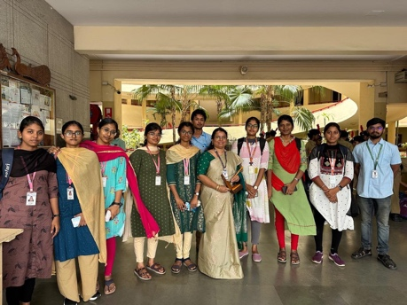
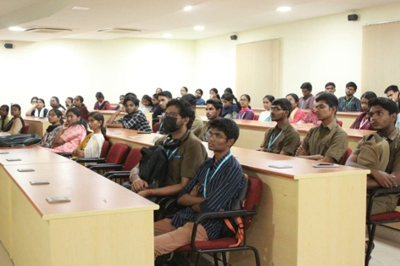
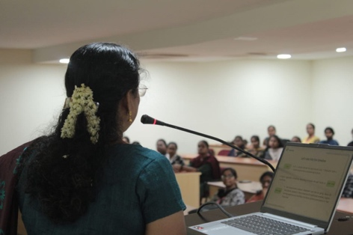

SRC KUMBAKONAM, Nelthiruvizha. ORGAGEN STUDENTS’ Club Orientation
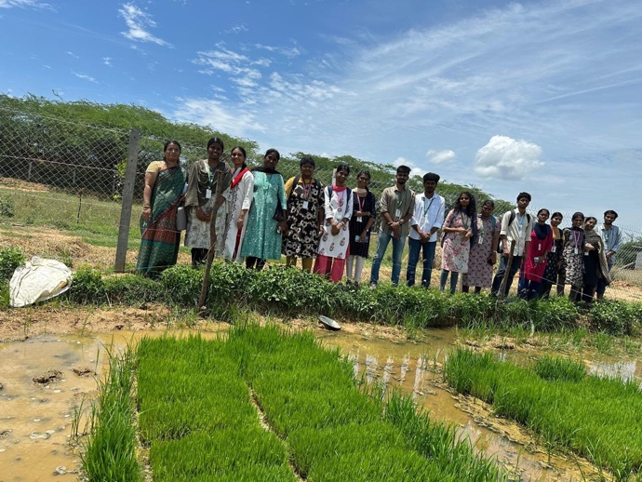

Mat Nursery field visit at paddy fields of SASTRA

